­­

Dialogflow is an excellent website that helps in creating bots.

To work with dialogflow nagivate to <https://dialogflow.com/> and log in using your existing email-id

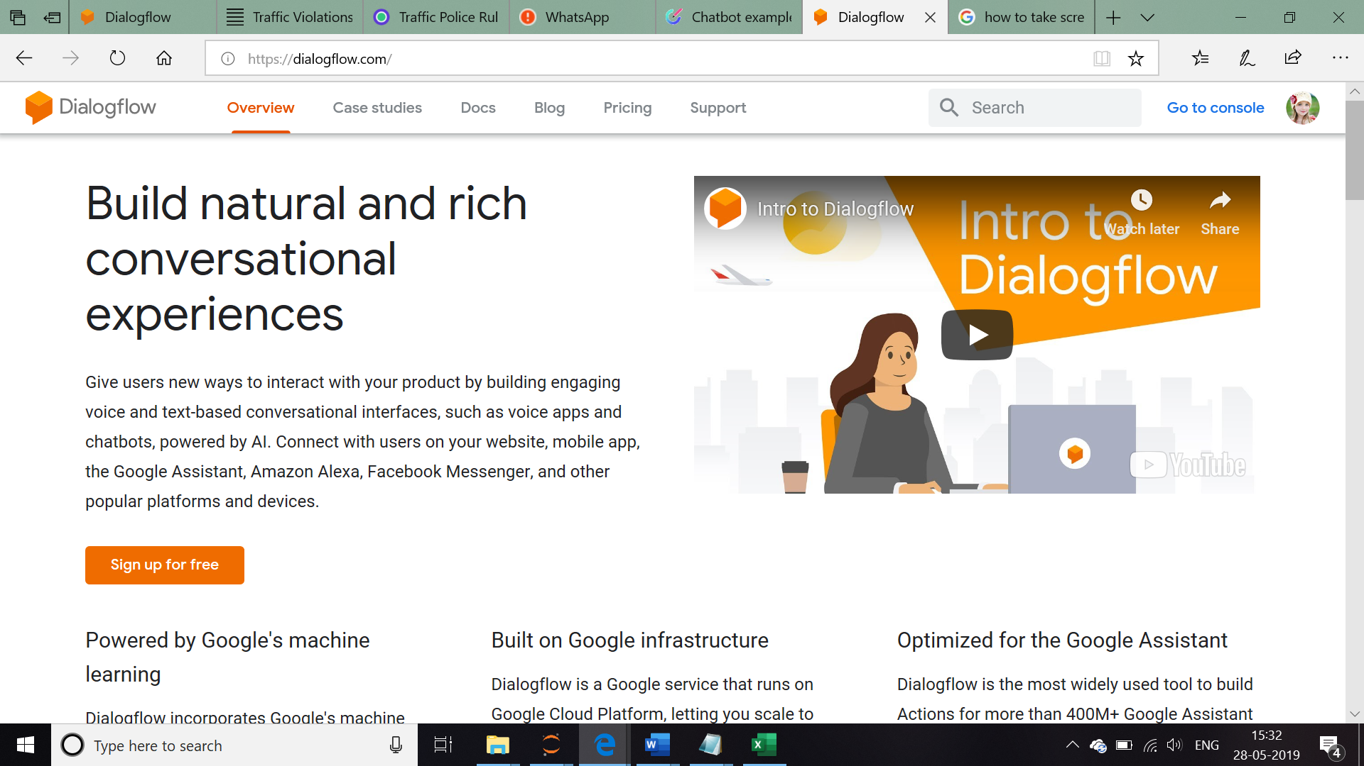

Using dialogflow, We are going to create a chat bot which helps in getting more details related to the ***Type of Traffic Voilation*** , **and provides help with the appropriate penalty. This bot takes name, mobilenumber and email-id from the user to send details.**

The first step in developing this bot is creation of agent which interacts with the User. Follow the steps below to create an agent.

Go to the **Drop down arrow** which is located just below the dialogflow logo, and select **‘CREATE AGENT’**

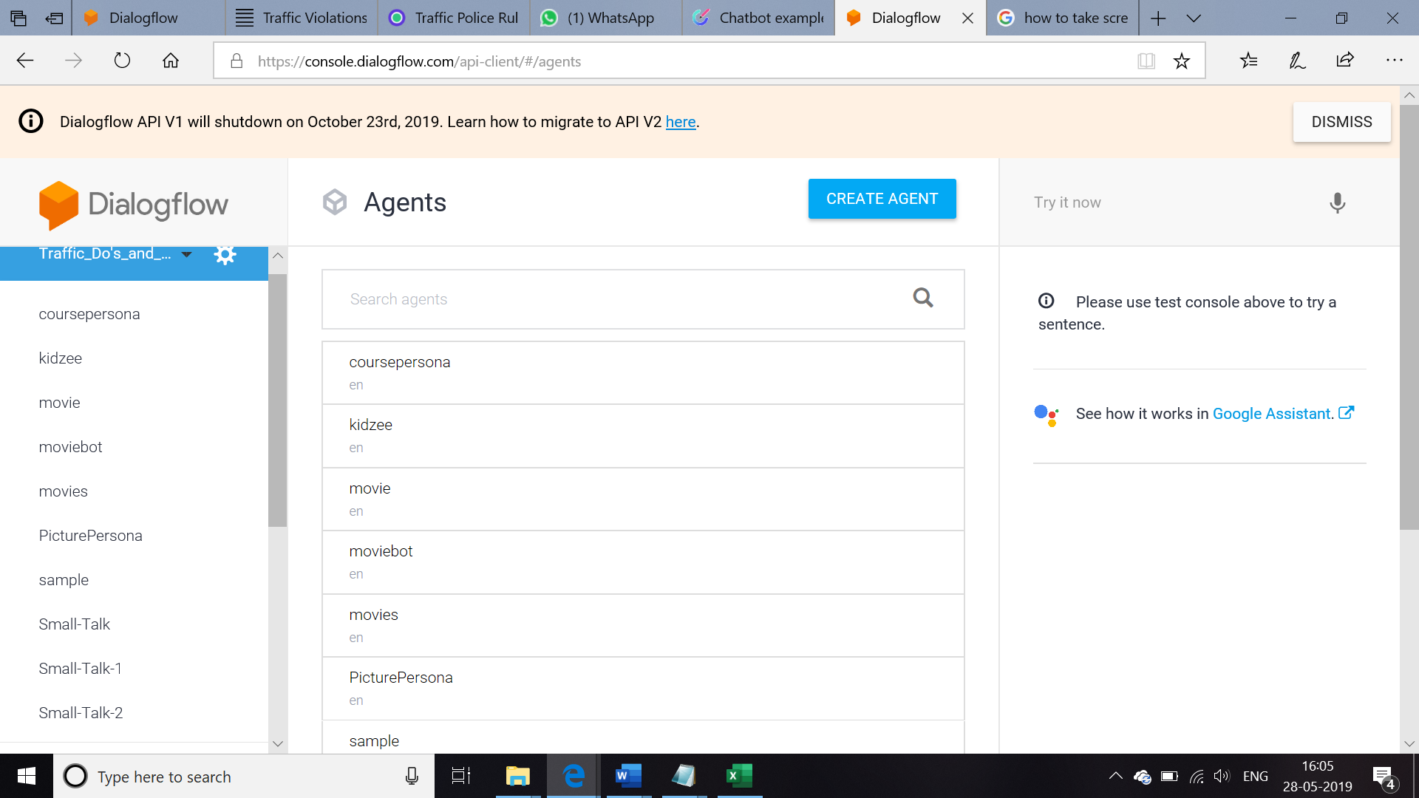

The screen looks like below

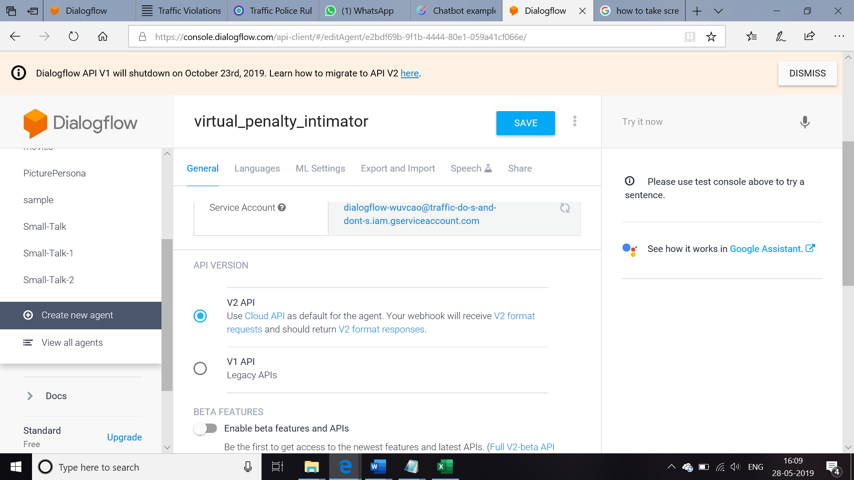

Type the name for our agent lets take ‘virtual_penalty-intimator’ and **click save**

Now the agent will be created .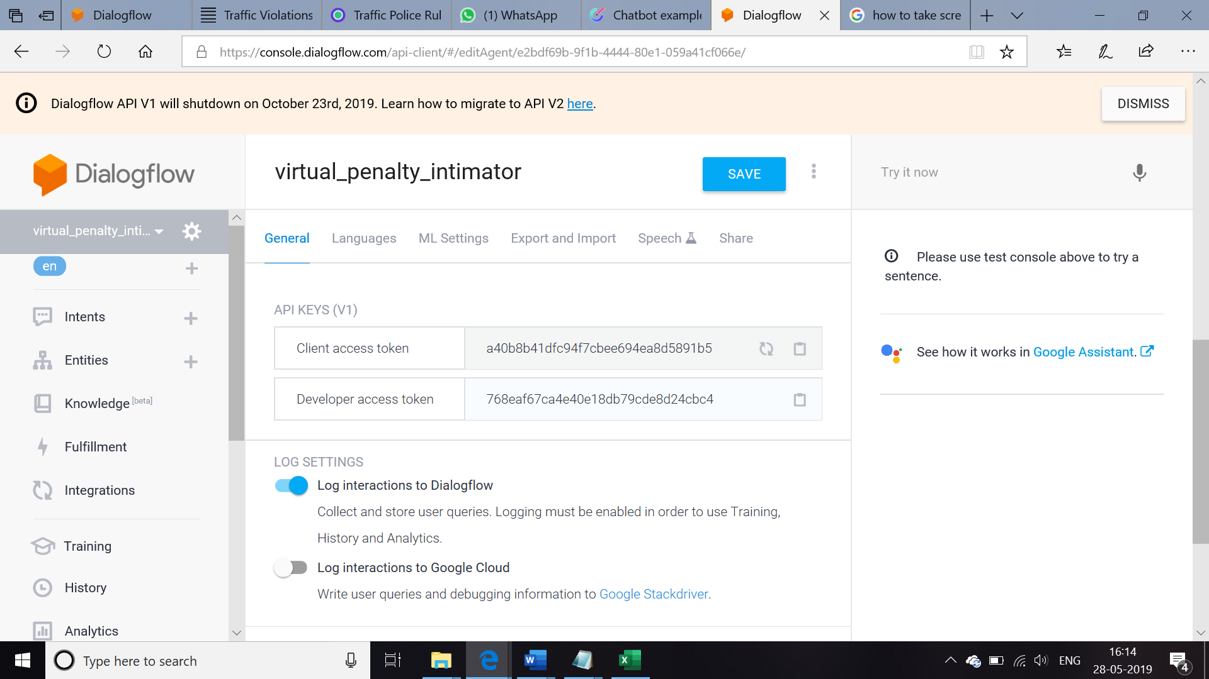

We can confirm the name of the agent from the page.

Create chat sequence that the **virtual_penalty_intimator** should follow based on the input from the user

To start with the entire setup ,

**Click Intents** and you can look at the following screen

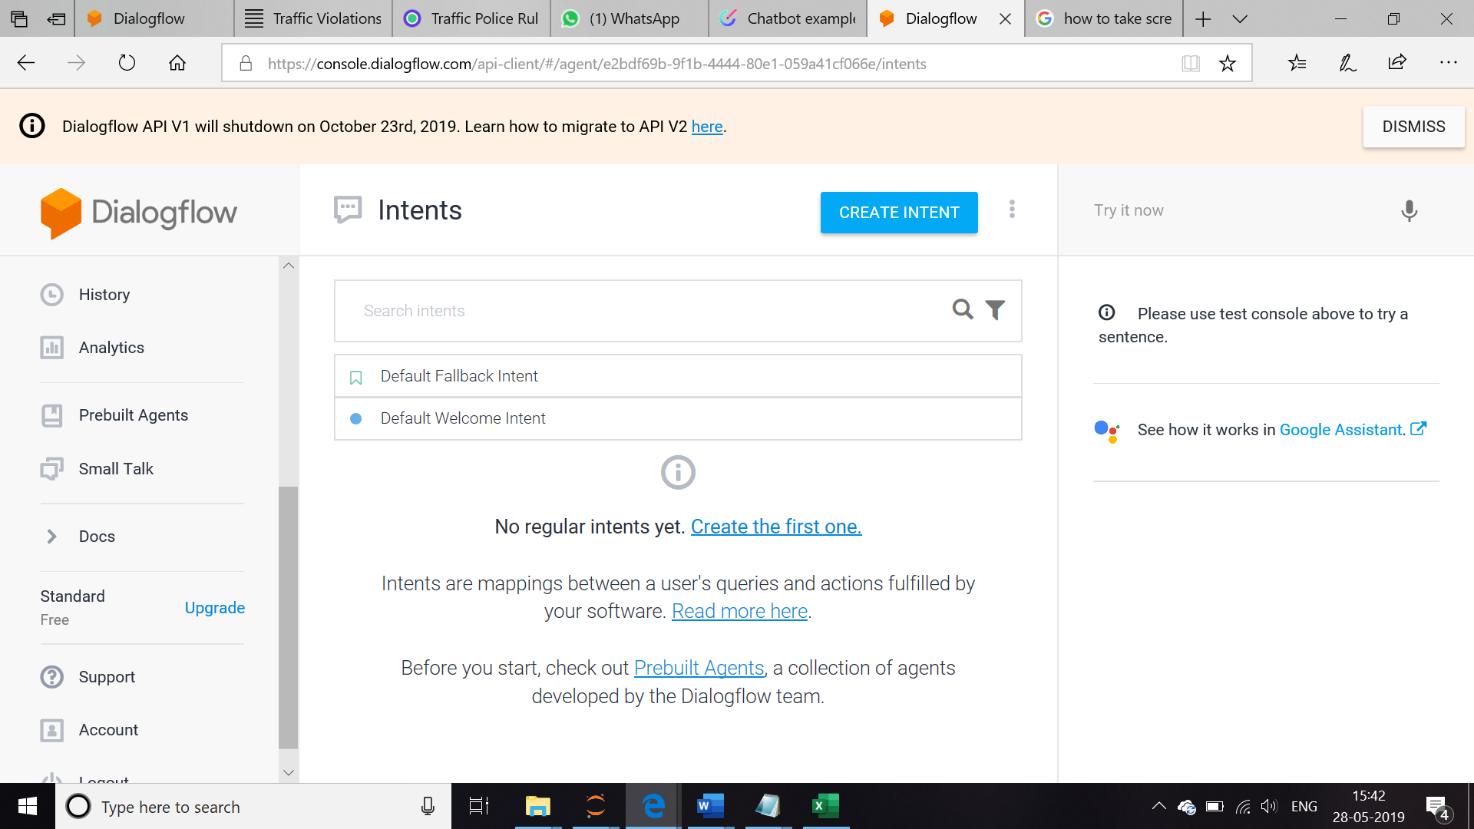

There are two types of Intent. **Default Fallback intent and Default Welcome Intent**

**Default Welcome Intent: Whenever a user starts communicating with the chat bot what are the words he can use like hai, hello , hey there, goodmorning** …

**And whenever our bot want to respond to the user based on his /her input** , like

If I am a User , I will start with hi ,

Then my bot should respond me based on the word hi

To make this happen lets go in to the **Default Welcome Intent and click , you can look at the screen with the default words to start a conversation.**

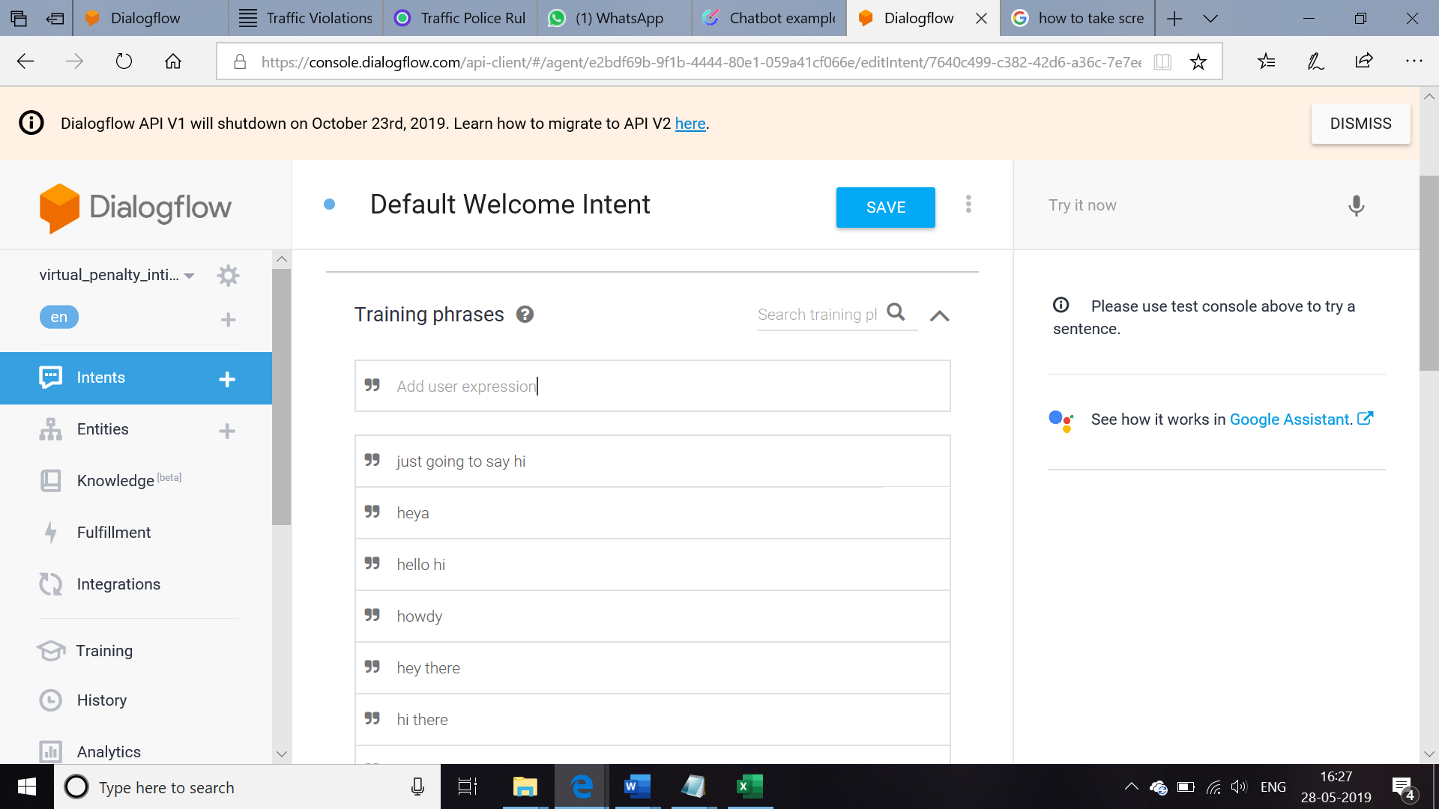

In the Training Phrase

Lets add several words to start conversation ,these words denote what are all the words theuser can use while he / she starts with the conversation ,just **type the words and press enter.**

After adding one by one theTraining Phrase look like this

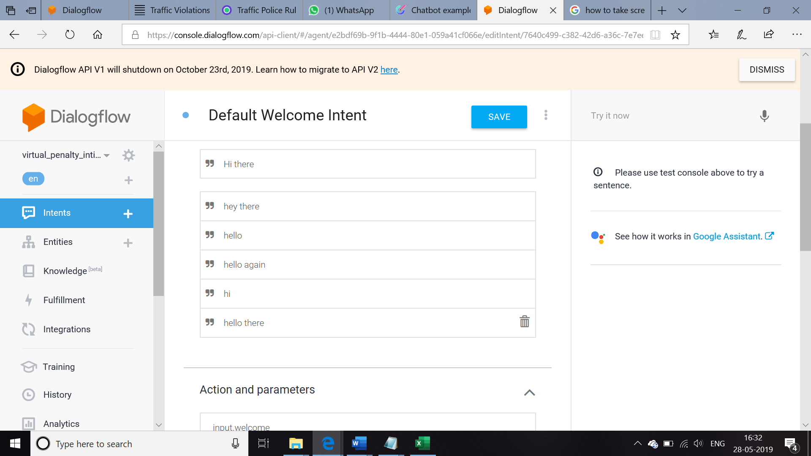

Next moving on to the responses , bot should respond to the User based on the words given here.

Scroll down and Go to the **Responses** to look like the screen below 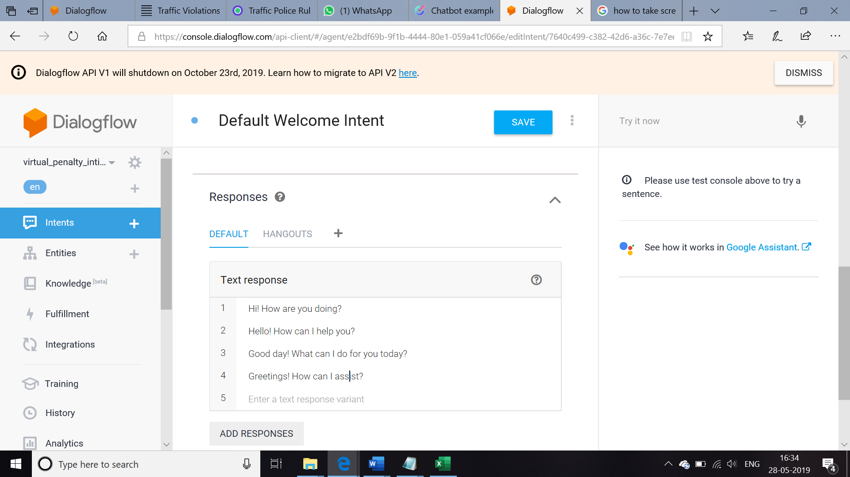

Now type the responses our chat bot need to respond

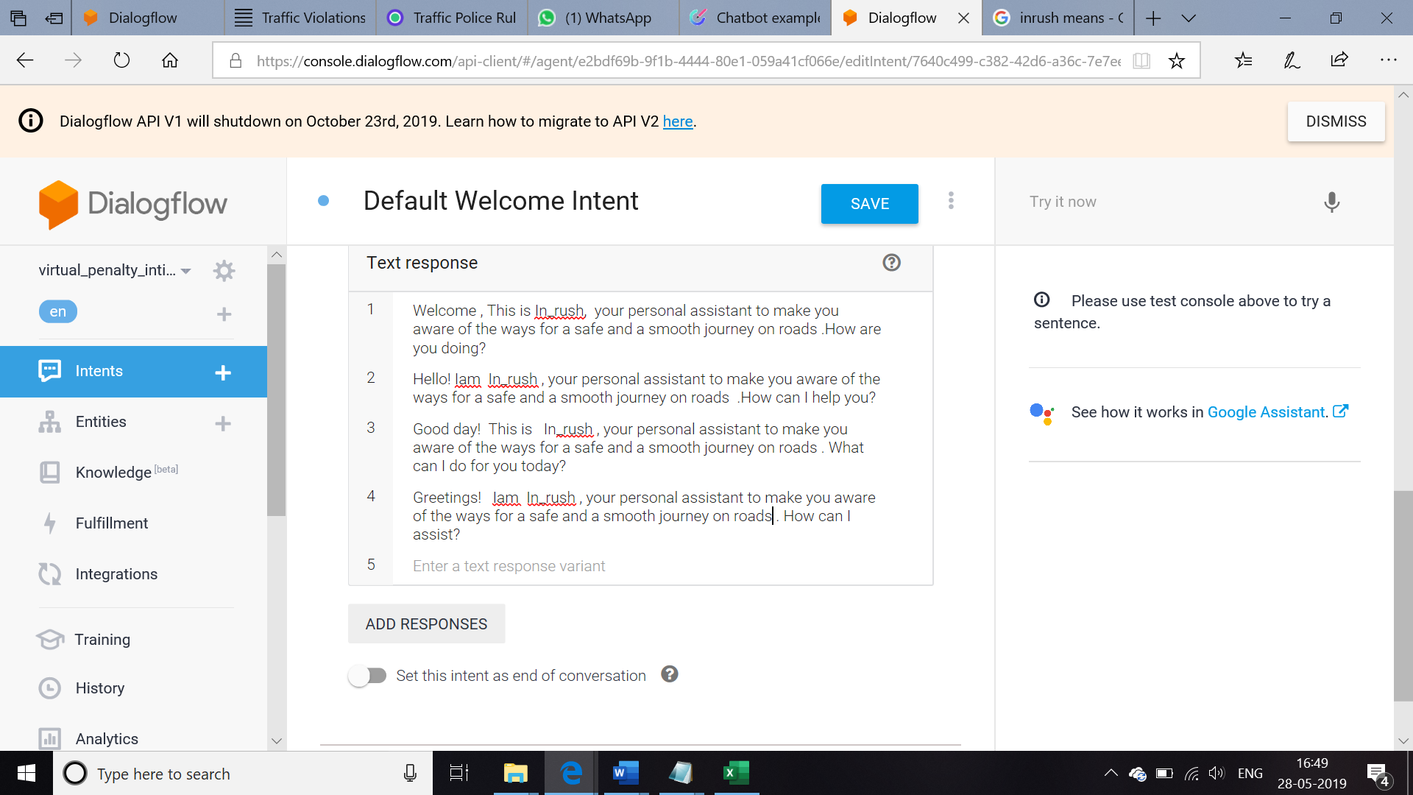

Click **Save** to make the changes done

Below the **DISMISS** The entire part is the test console where the built conversation is tested ,to proceed further type hi and press enter

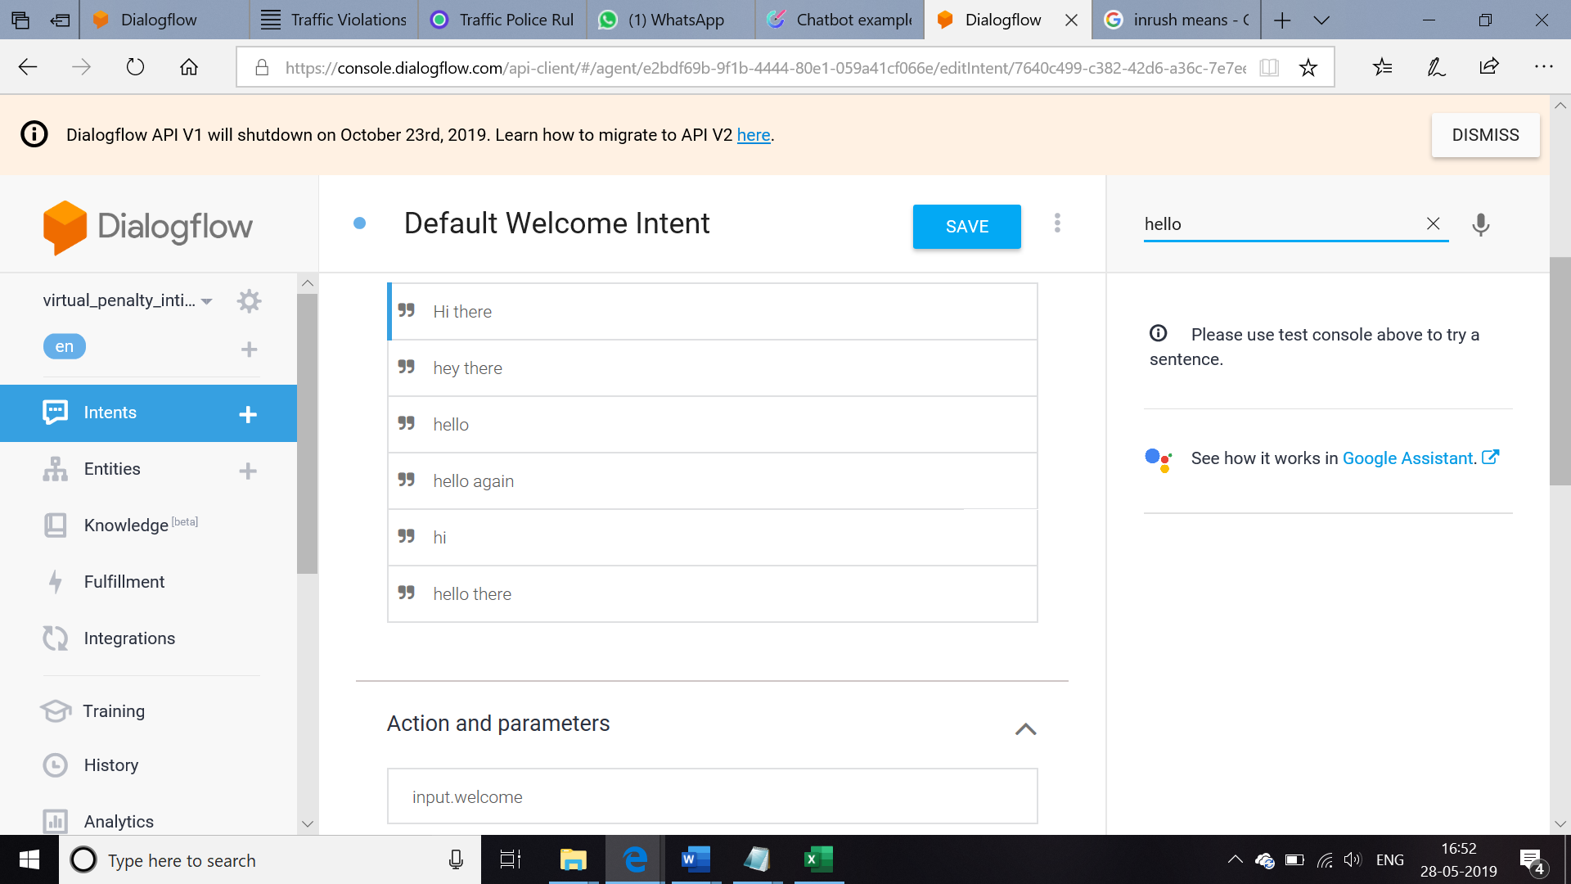

look at the below screen

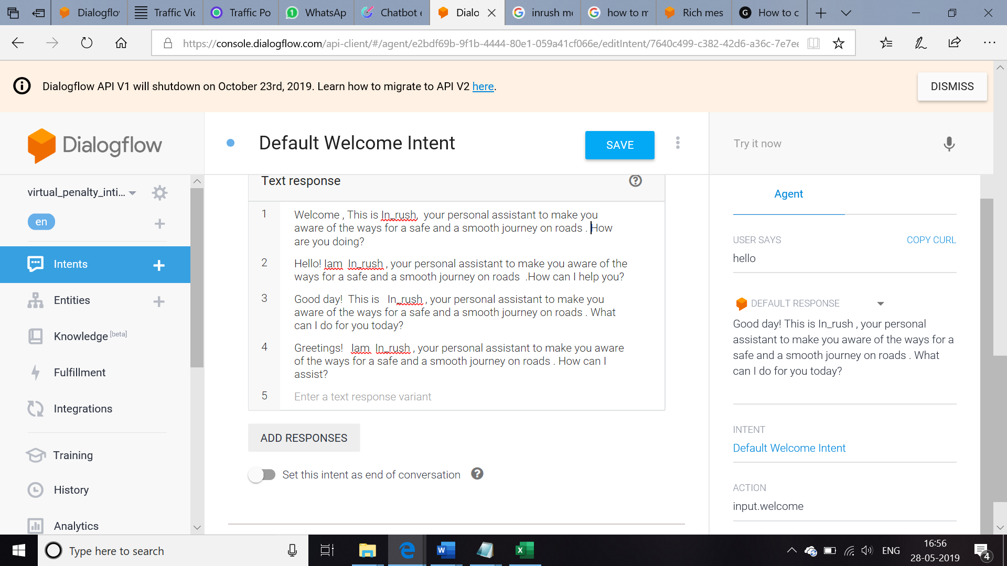

Now coming to the next part , bot is not only going to tell us the smooth ways to drive , besides

It is going to tell even it can handle **the penalty charged for the traffic violations ,** so that the users know that the bot can even handle that by including this in the next response as shown below 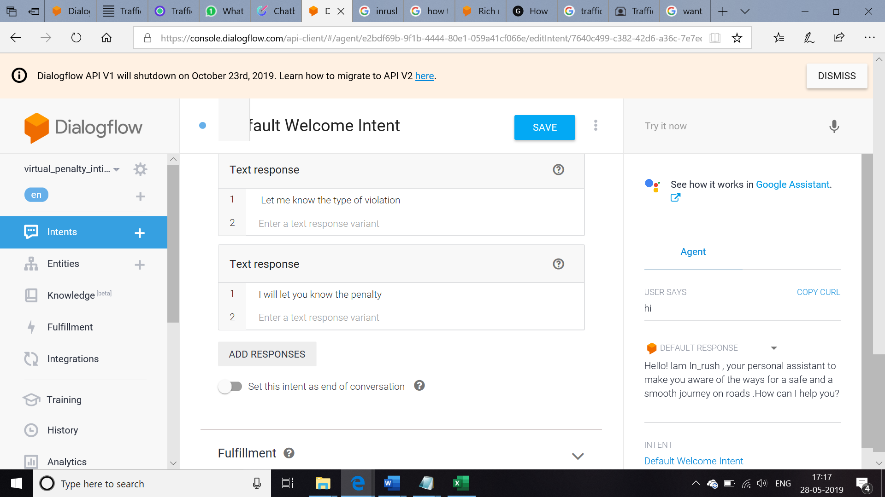

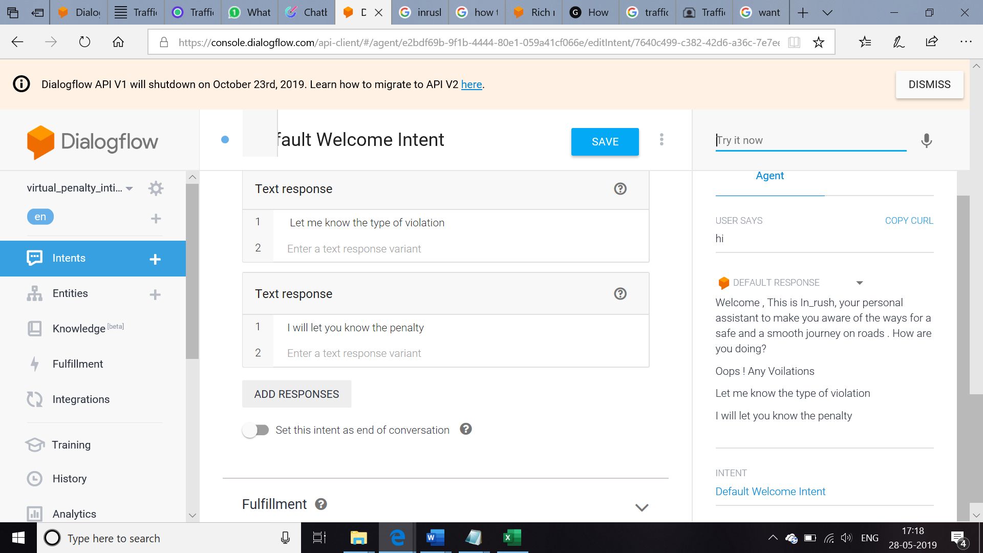

Now welcome intent is done Next , In order to create a chat bot based on the context of the user , Intent should be created.

Click on ‘ CREATE INTENT’ will show the screen

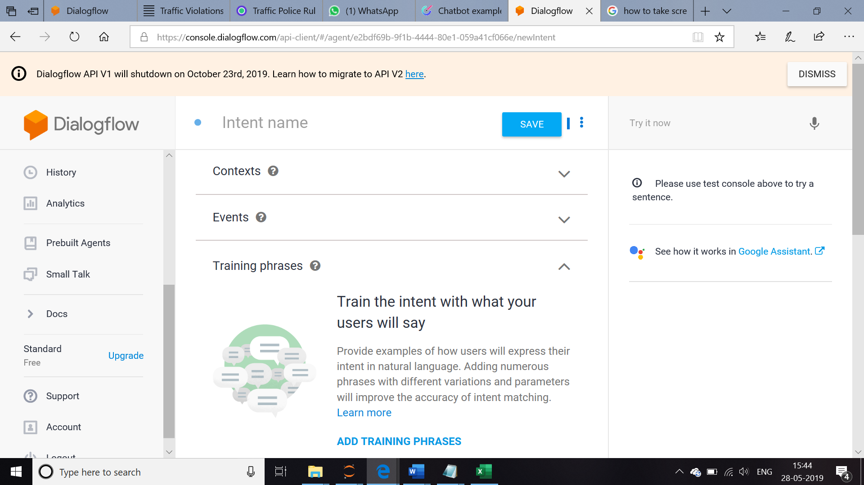

4. The name is user name and details and **click save**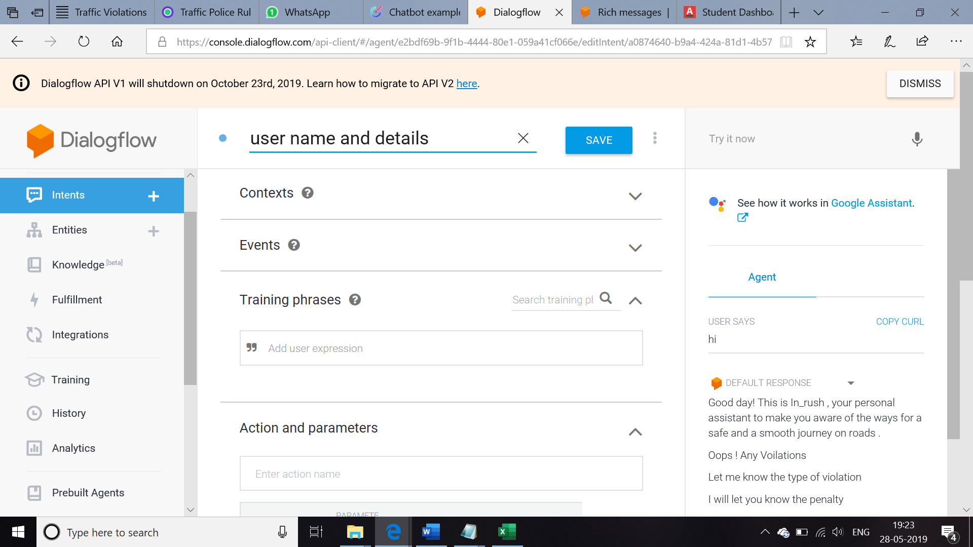

In order to know the chat bot is aware of the user details we are creating an entity , to create entity Choose **Entities from the dropdown** menu and give a name

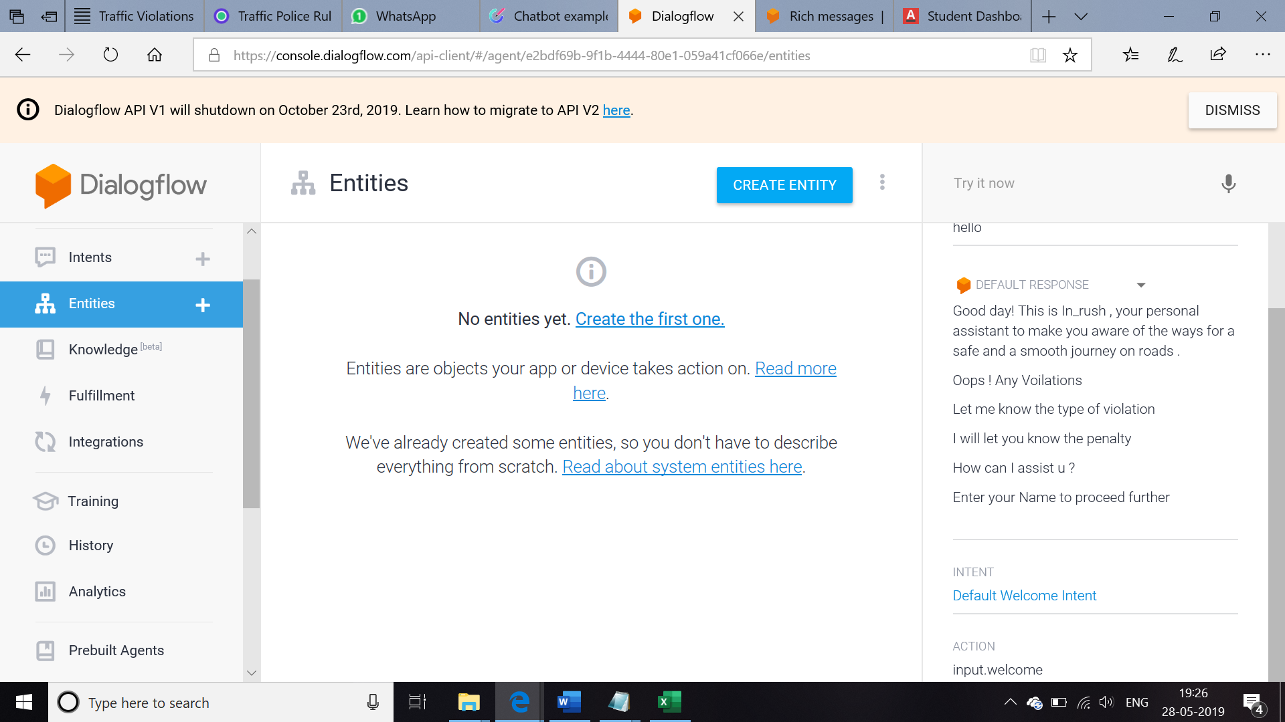

And Click ‘**CREATE ENTITY’**  add the list of the names so that it will be recognised

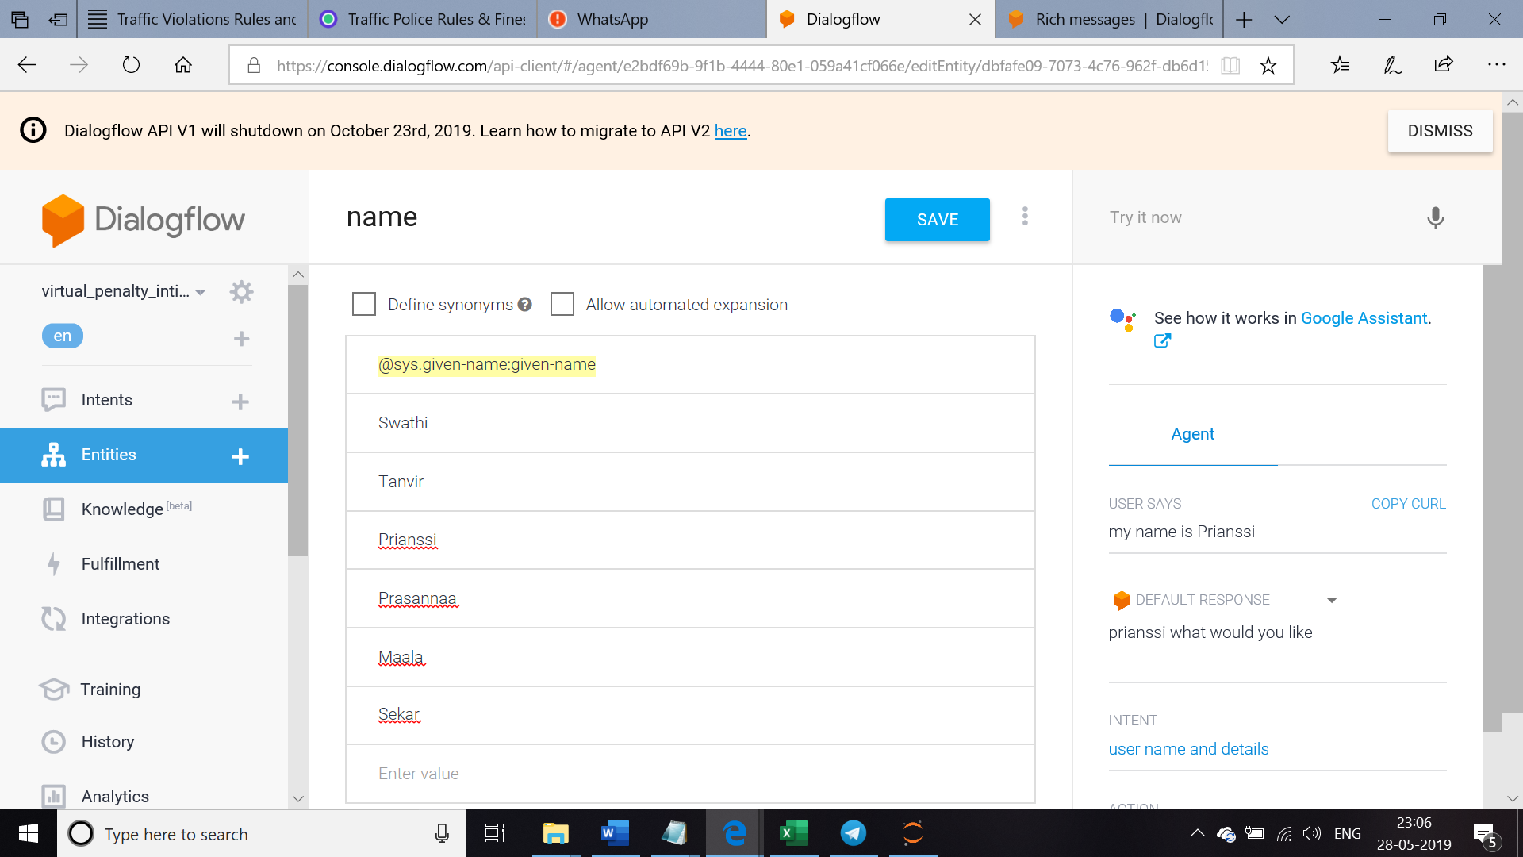

Next create the conversation based on the penalty

create the various intents one by one

* ***Exceeding the maximum speed Intent***

Whenever the user needs the penalty for exceeding the maximum speed ,this intent gets fired , so add the respective training phrases as shown,

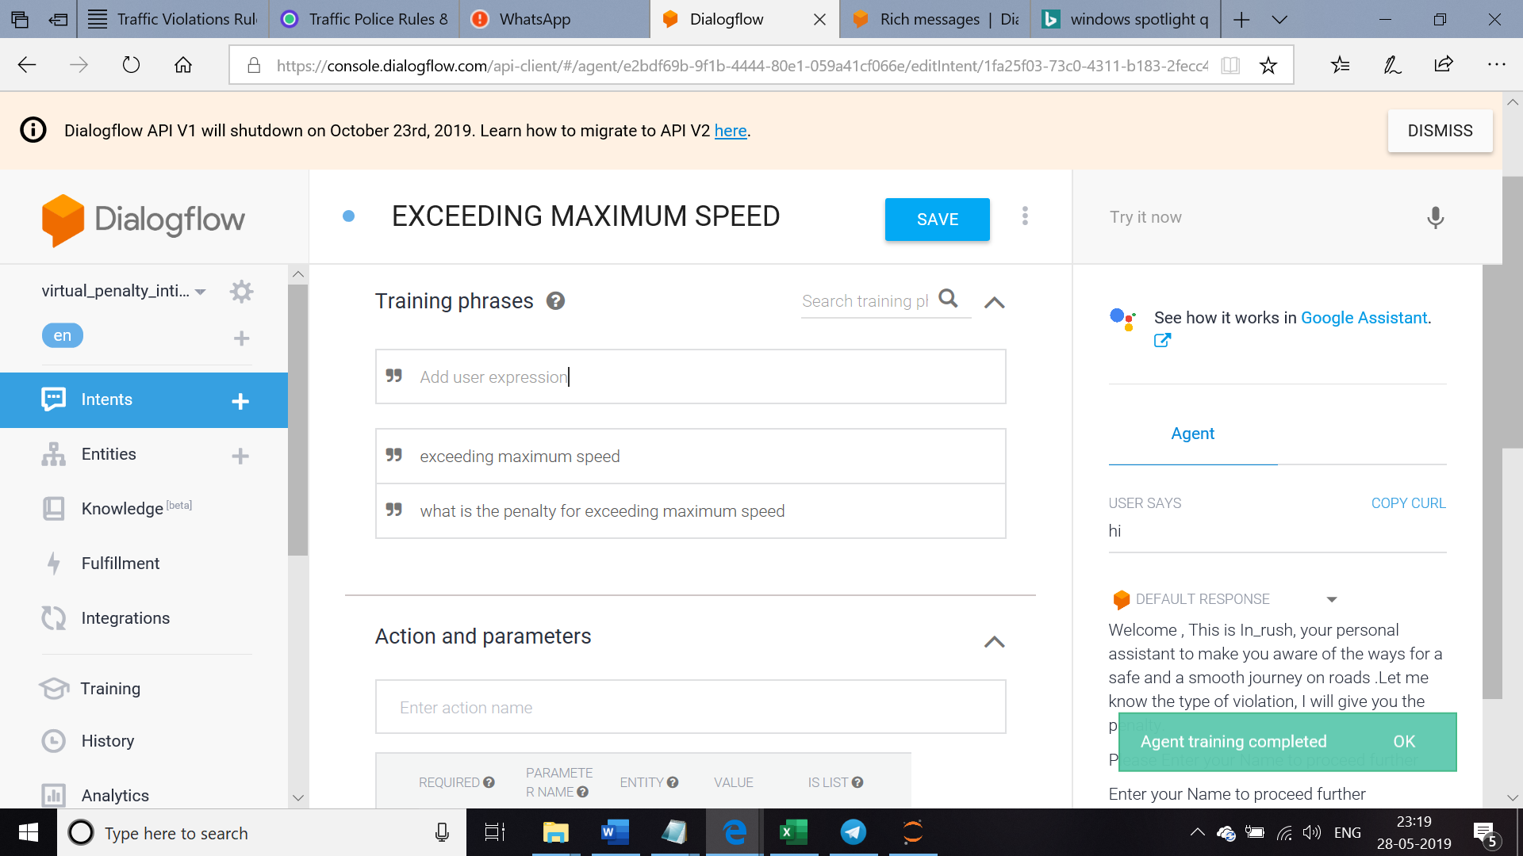

And the corresponding responses should be typed as shown below

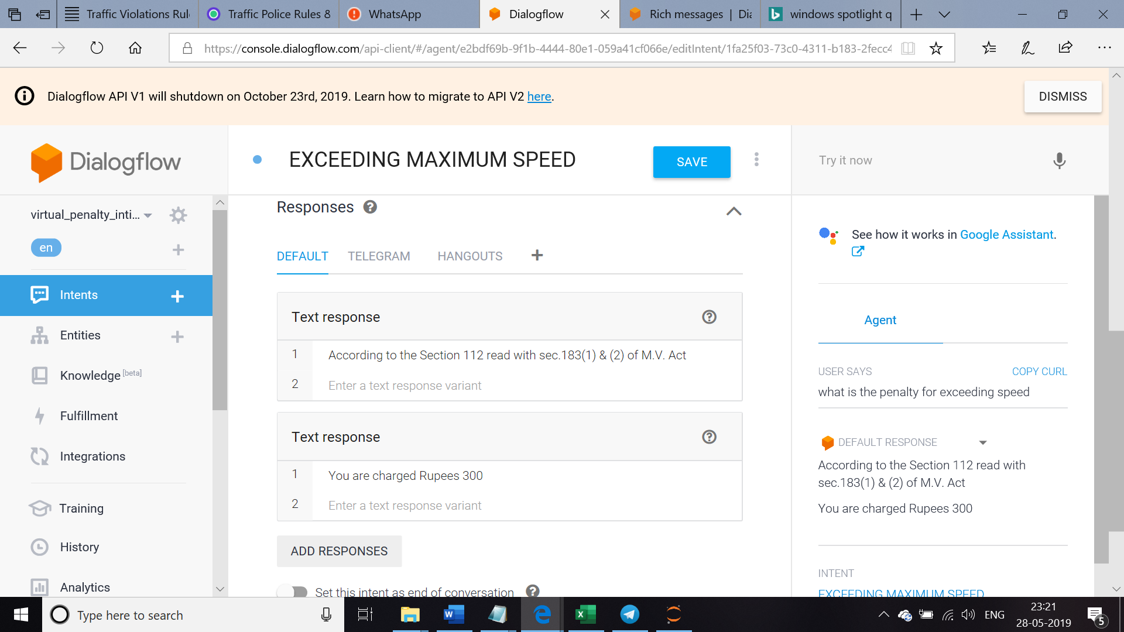

* ***Defective Silencer Intent***

Whenever the vehicle silencer is not working as expected this intent is fired, add the respective Training phrases as shown

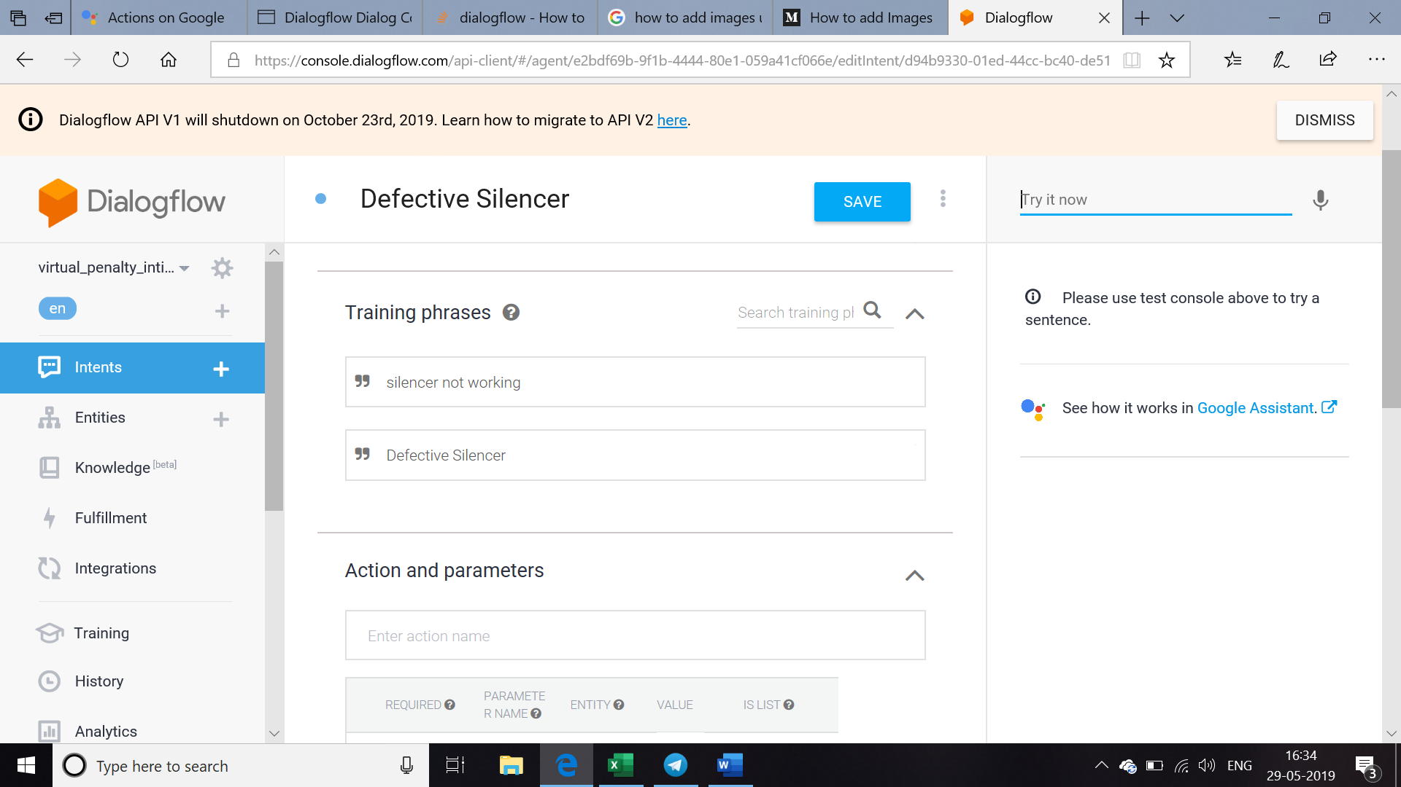

In the Response add the corresponding responses as shown and check the flow in the test console

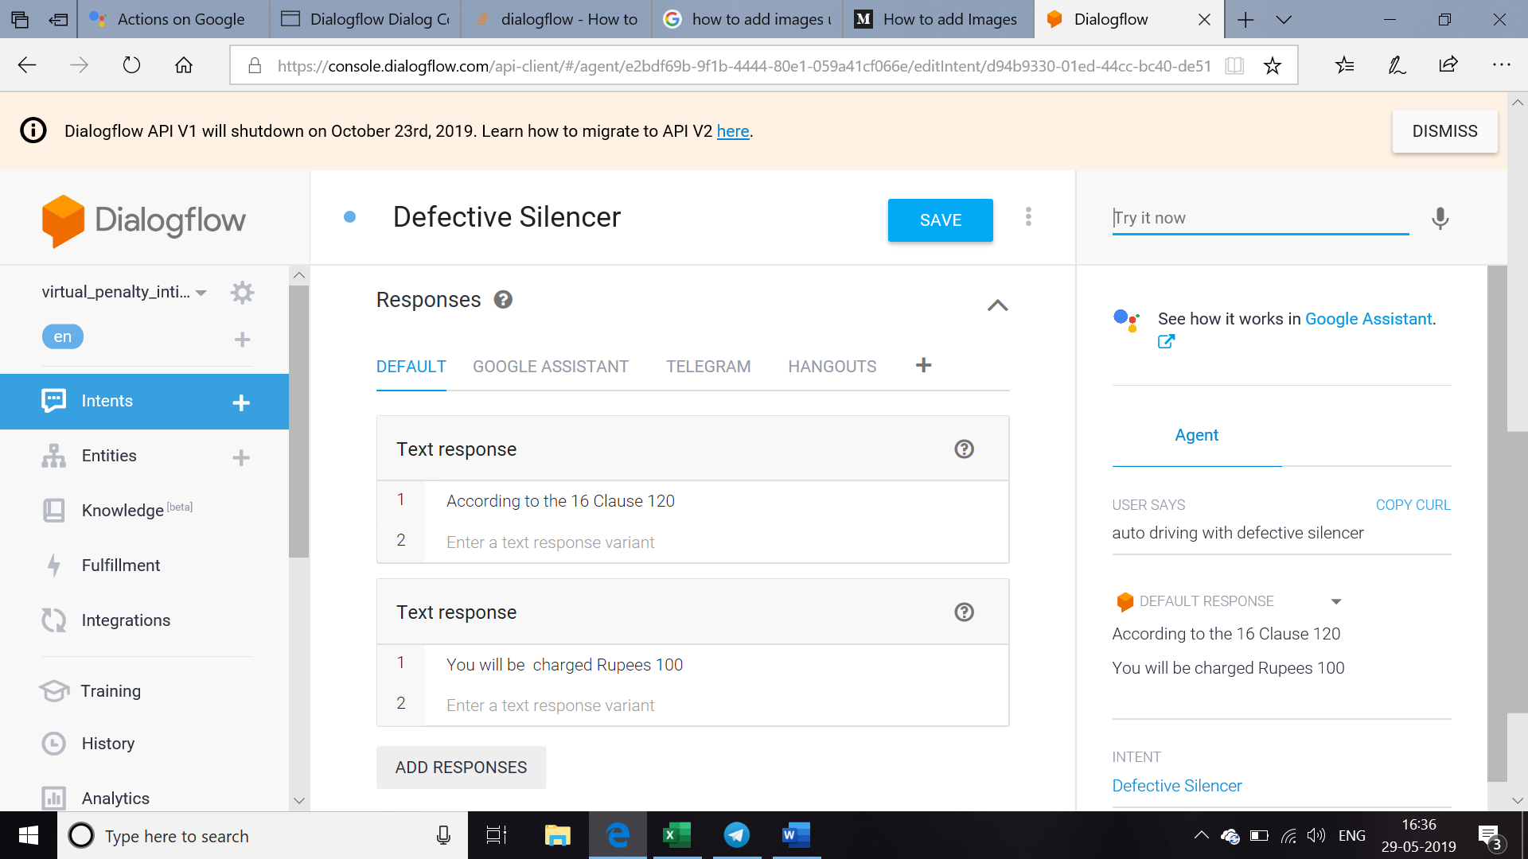

***Demanding Excess Fare and refusal to come for hire Intent***

Whenever the cab driver deny to come for hire or demands excess fare this intent gets fired

Add the corresponding training phrases as shown 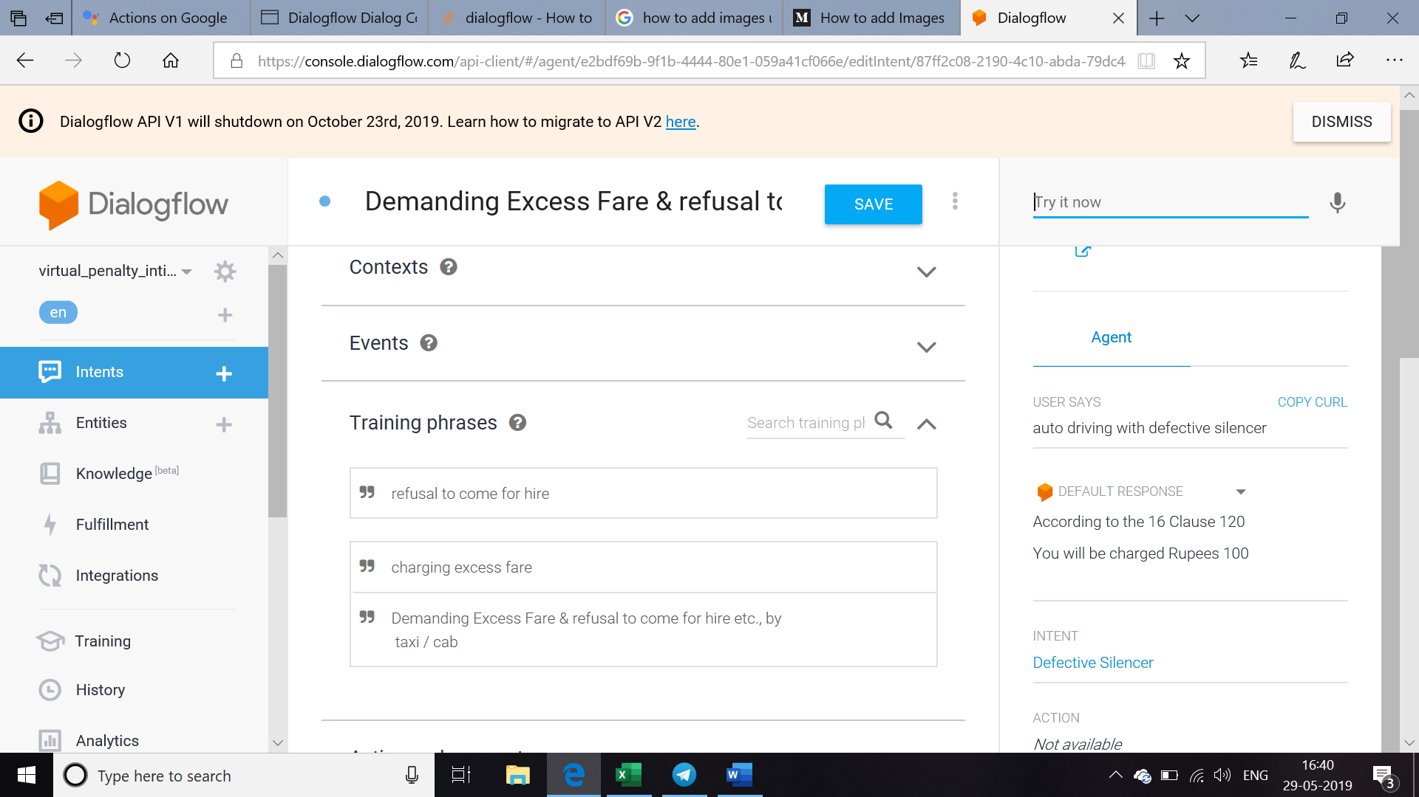

Add the corresponding response for this intent and check for the flow in the test console as shown

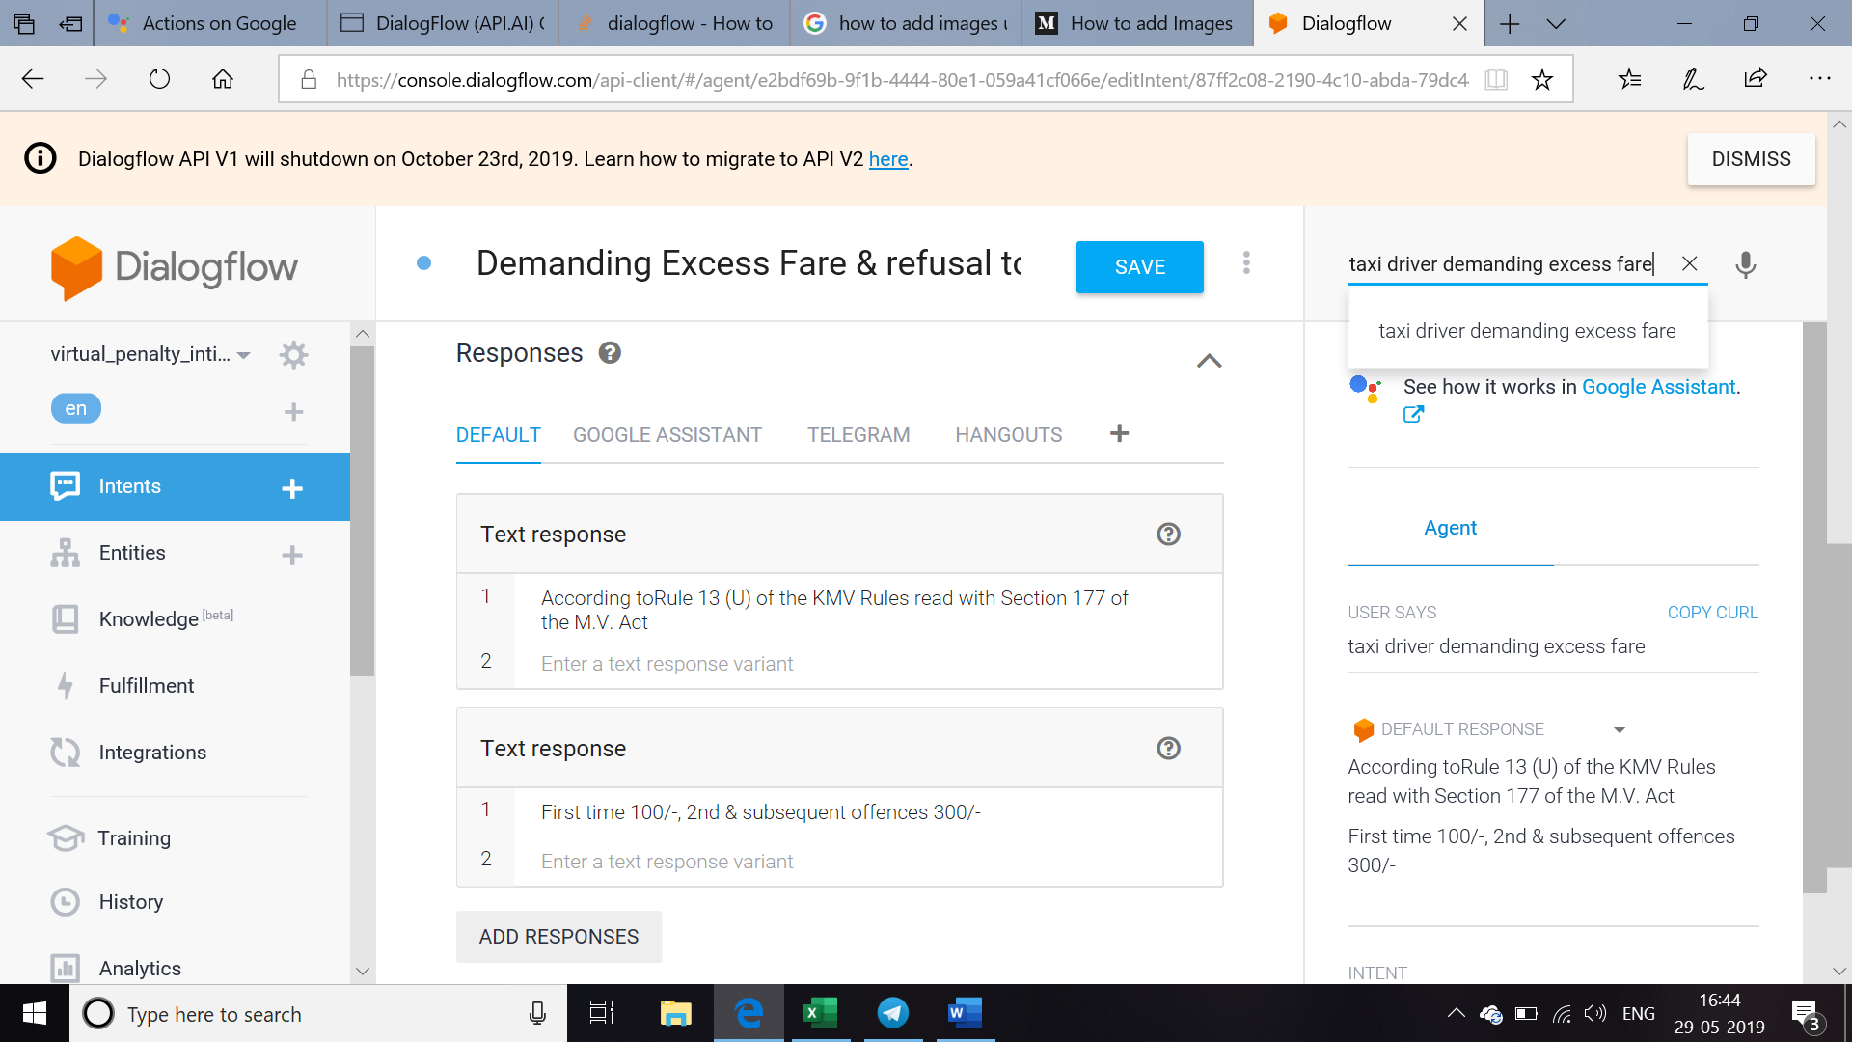

***Driving a motor vehicle in any public place by a underaged person Intent***

Whenever a under aged person drives on the public place this intent gets fired

Add the corresponding training phrase as shown below

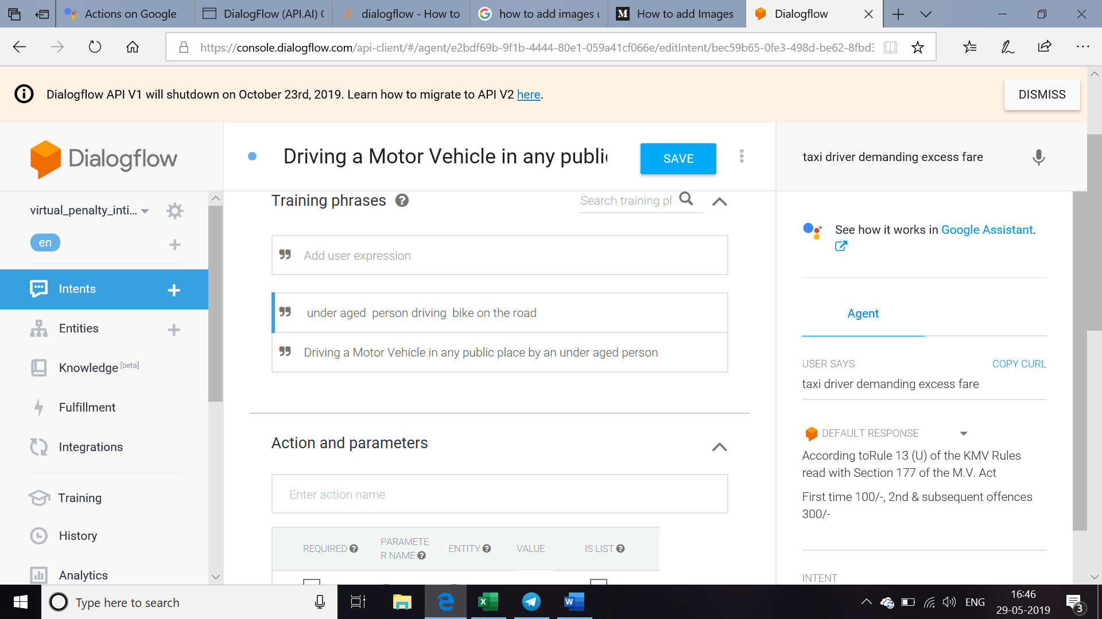

Add the corresponding response and check for the flow in the test console as shown

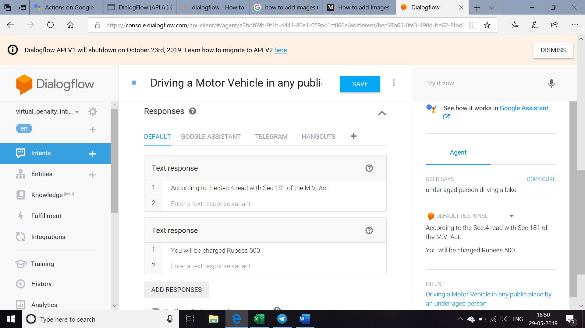

***Heavy Goods Vehicle -wrong parking Intent***

Whenever the heavy goods vehicles like tankers , truck , garbage truck , dumptruck , mobile crane is on the wrong parking this intent gets fired

Add the corresponding training phrase as shown

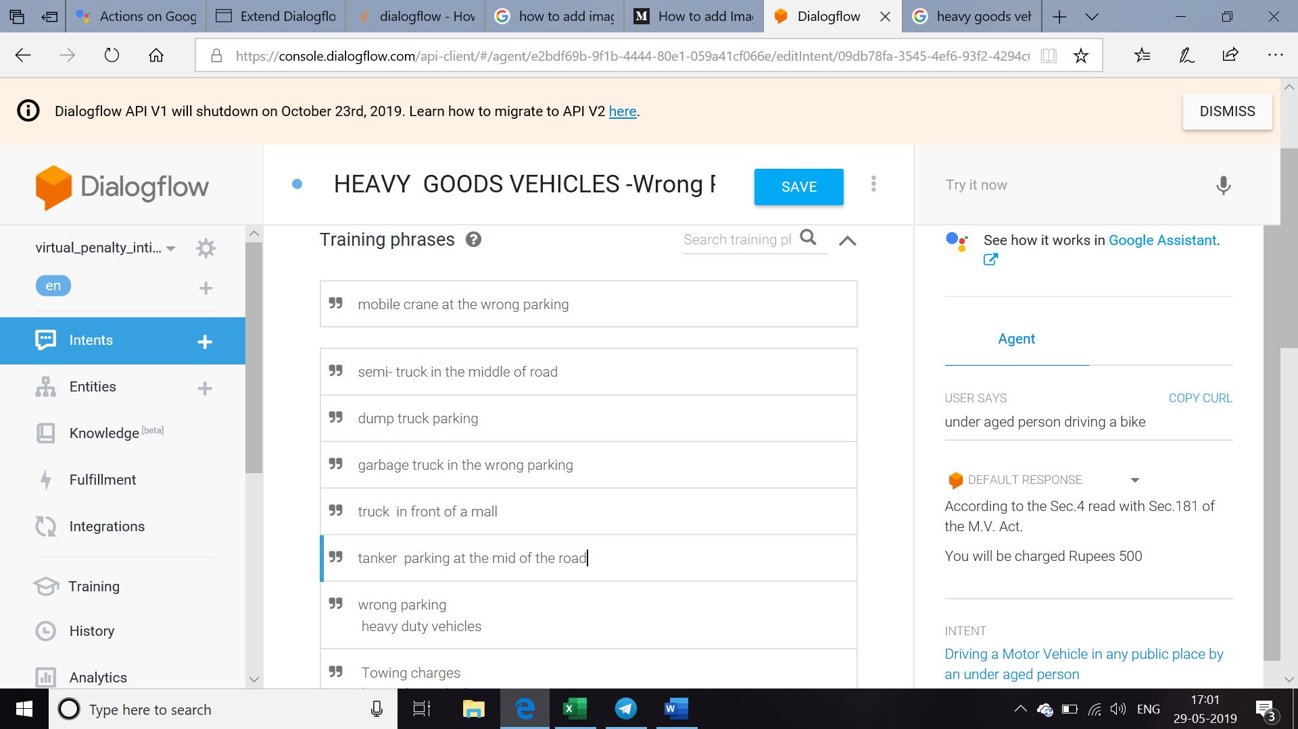

Add the corresponding responses and check for the flow in the test console as shown

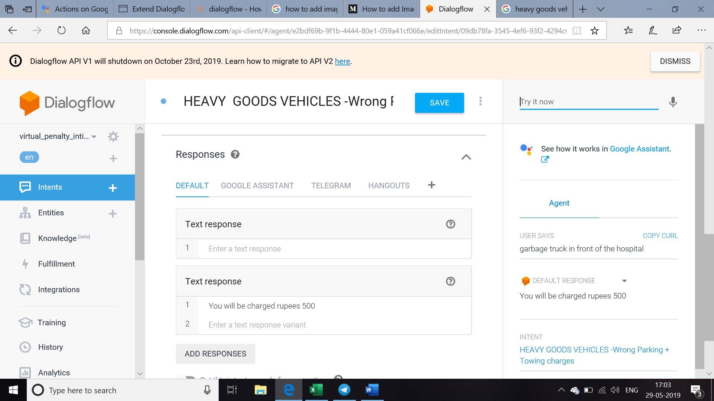

***Gents travelling in female seats in BMTC -bus Intent***

Whenever gents travel in the seats allotted for the females this intent is fired Add the corresponding training phrase as shown

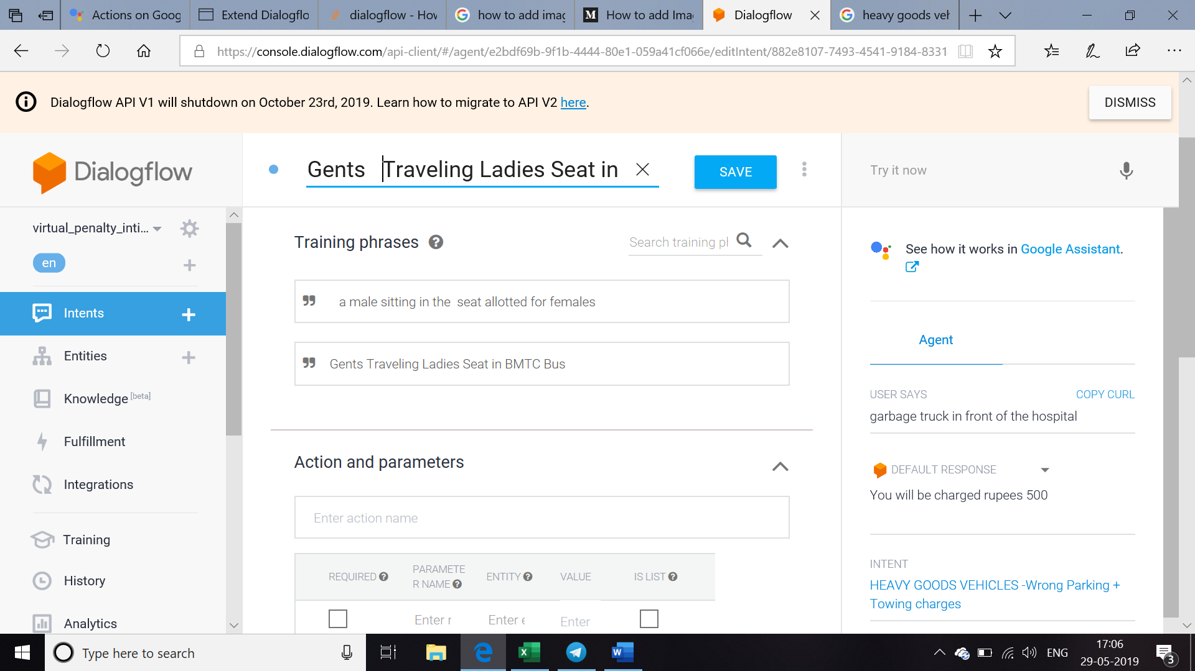

Add the corresponding responses and check for the flow in the test console as shown

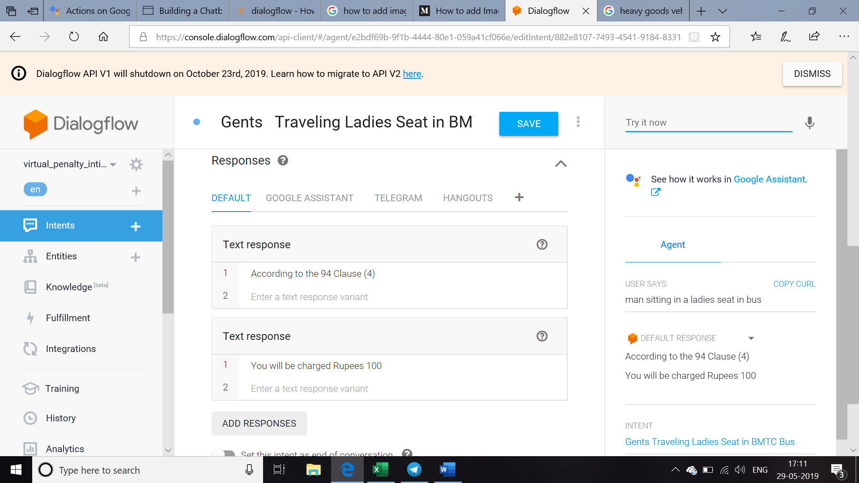

***Jumping Traffic Signal Intent***

Whenever the traffic signal is violated this intent gets fired

Add the corresponding training phrase as shown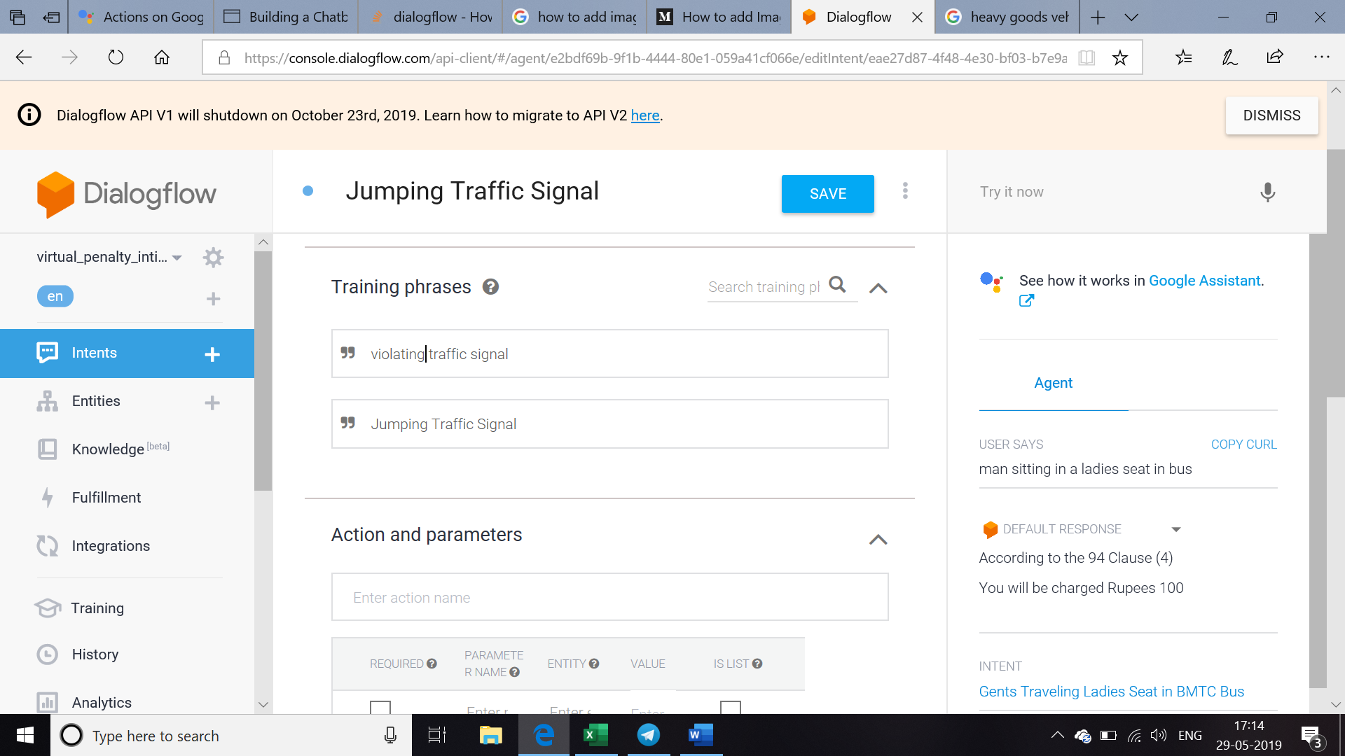

Add the corresponding responses and check for the flow in the test console as shown

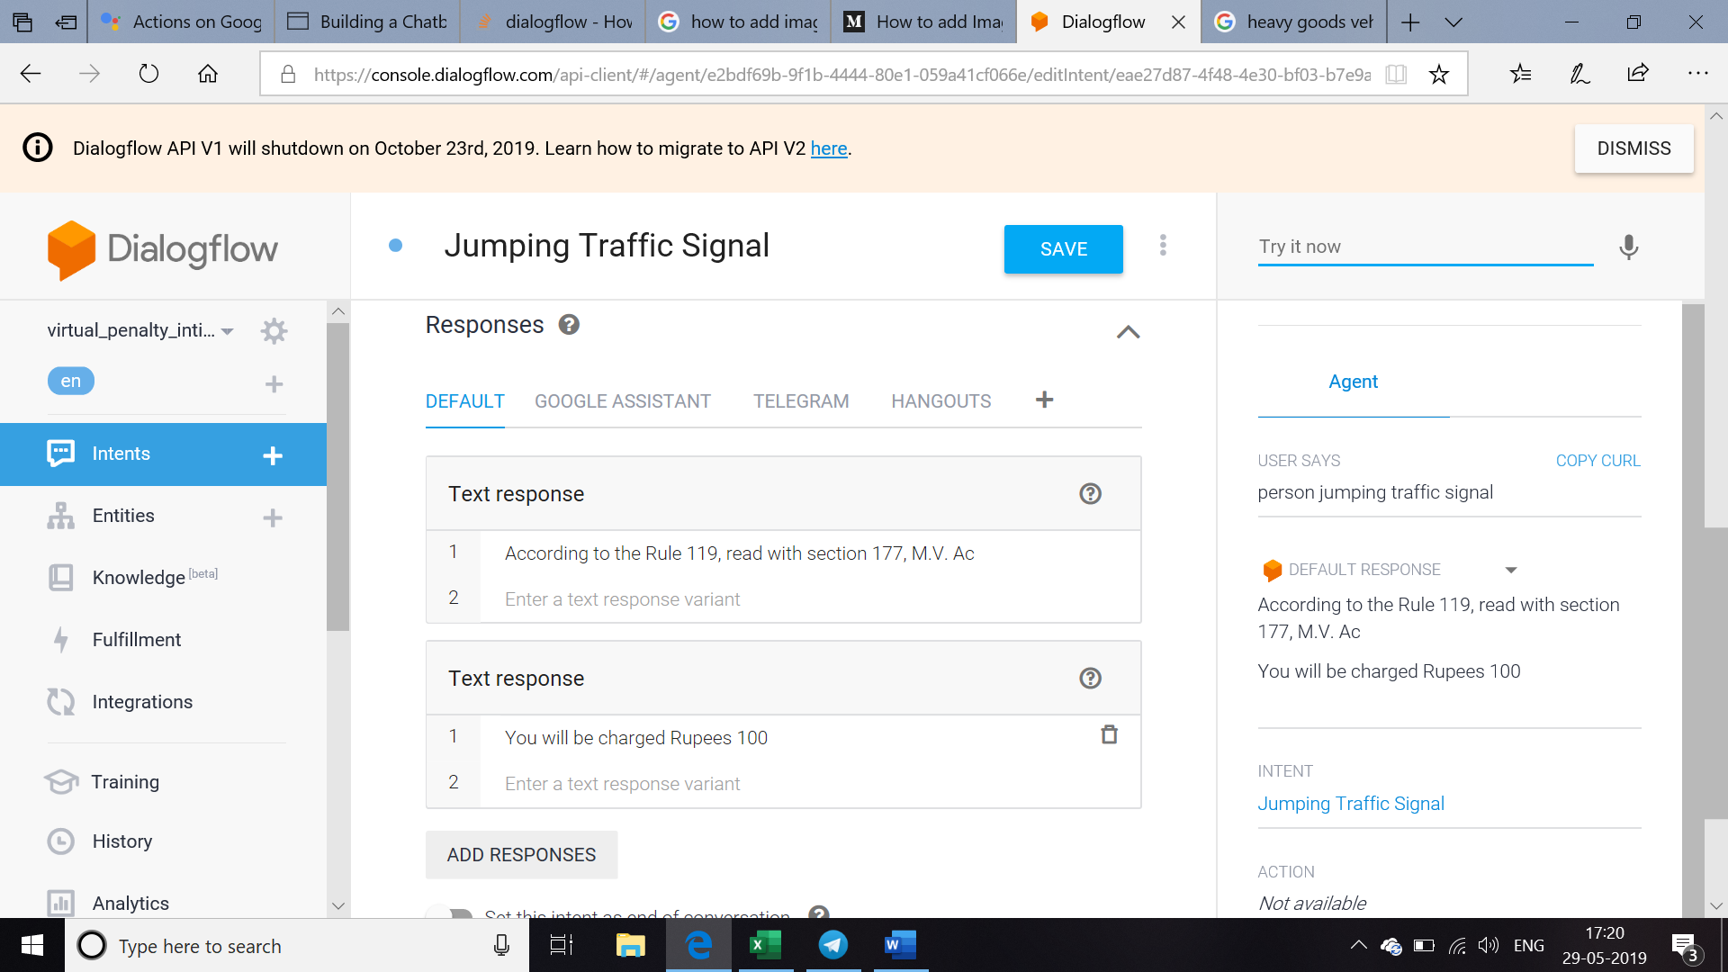

***Without Driving license Intent***

For a vehicle without driving license this intent gets fired

Add corresponding training phrase as shown

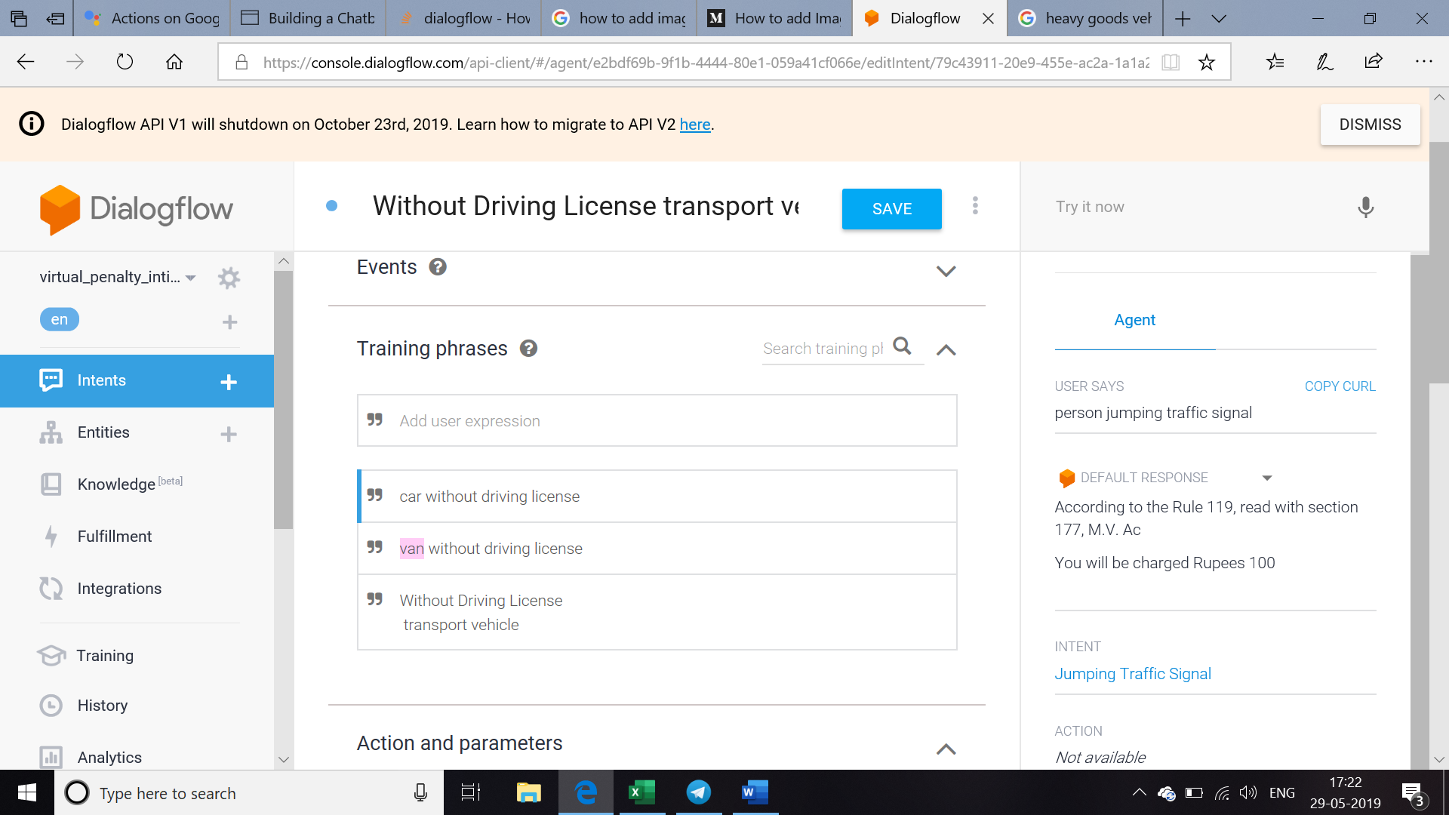

Add the respective responses and check for the flow in the test console a shown

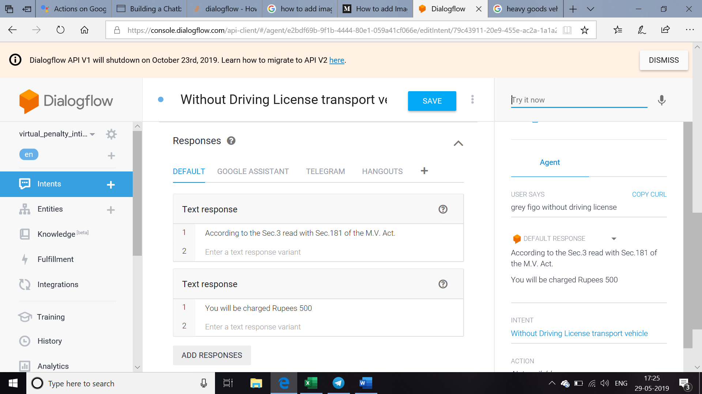

***Without Permit Intent***

For vehicles without permit this intent gets fired

Add the corresponding training phrase as shown

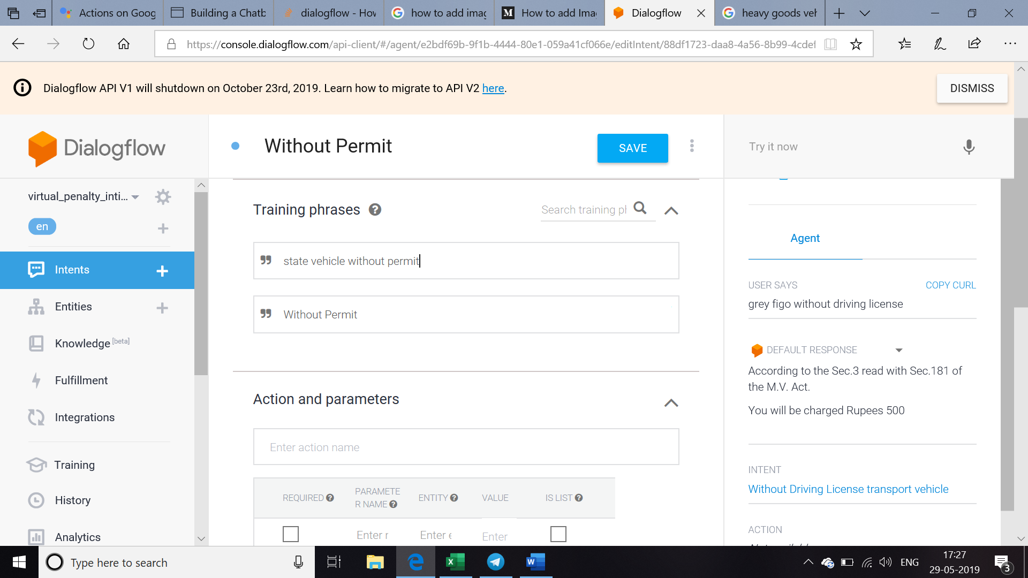

Add the corresponding responses and check for the flow in test console as shown

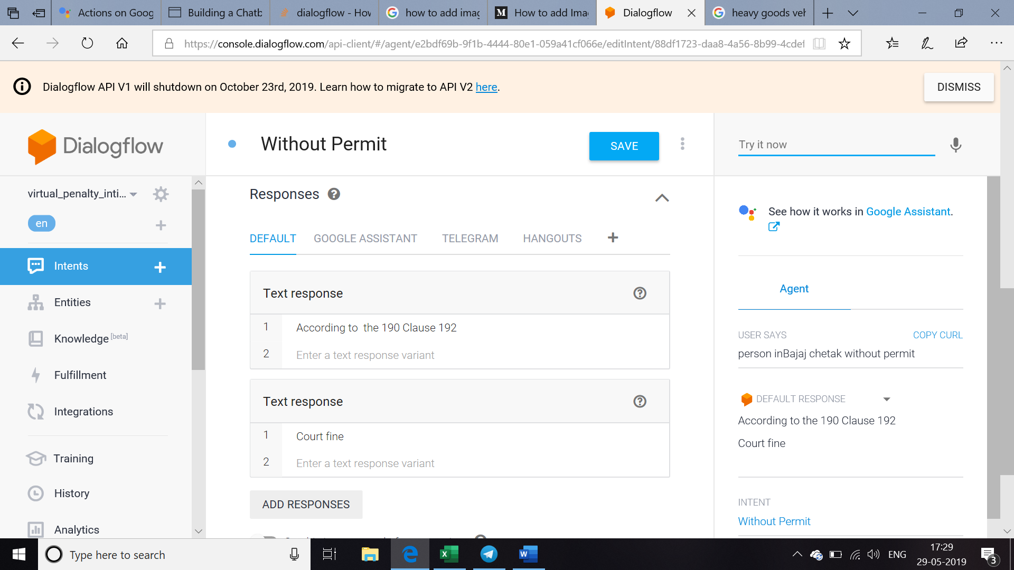

***Holding / Using Mobile Phone while driving - Intent***

Whenever a driving person uses mobile phone this intent gets fired

Add the corresponding training phrase as shown

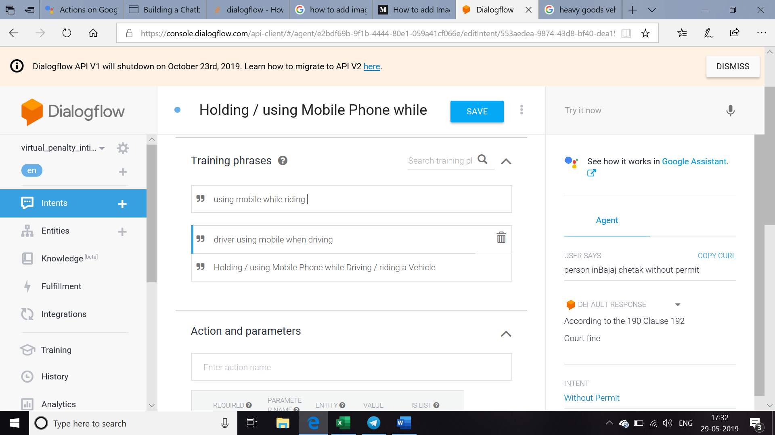

Add the respective response and check for the flow in the test console as shown below

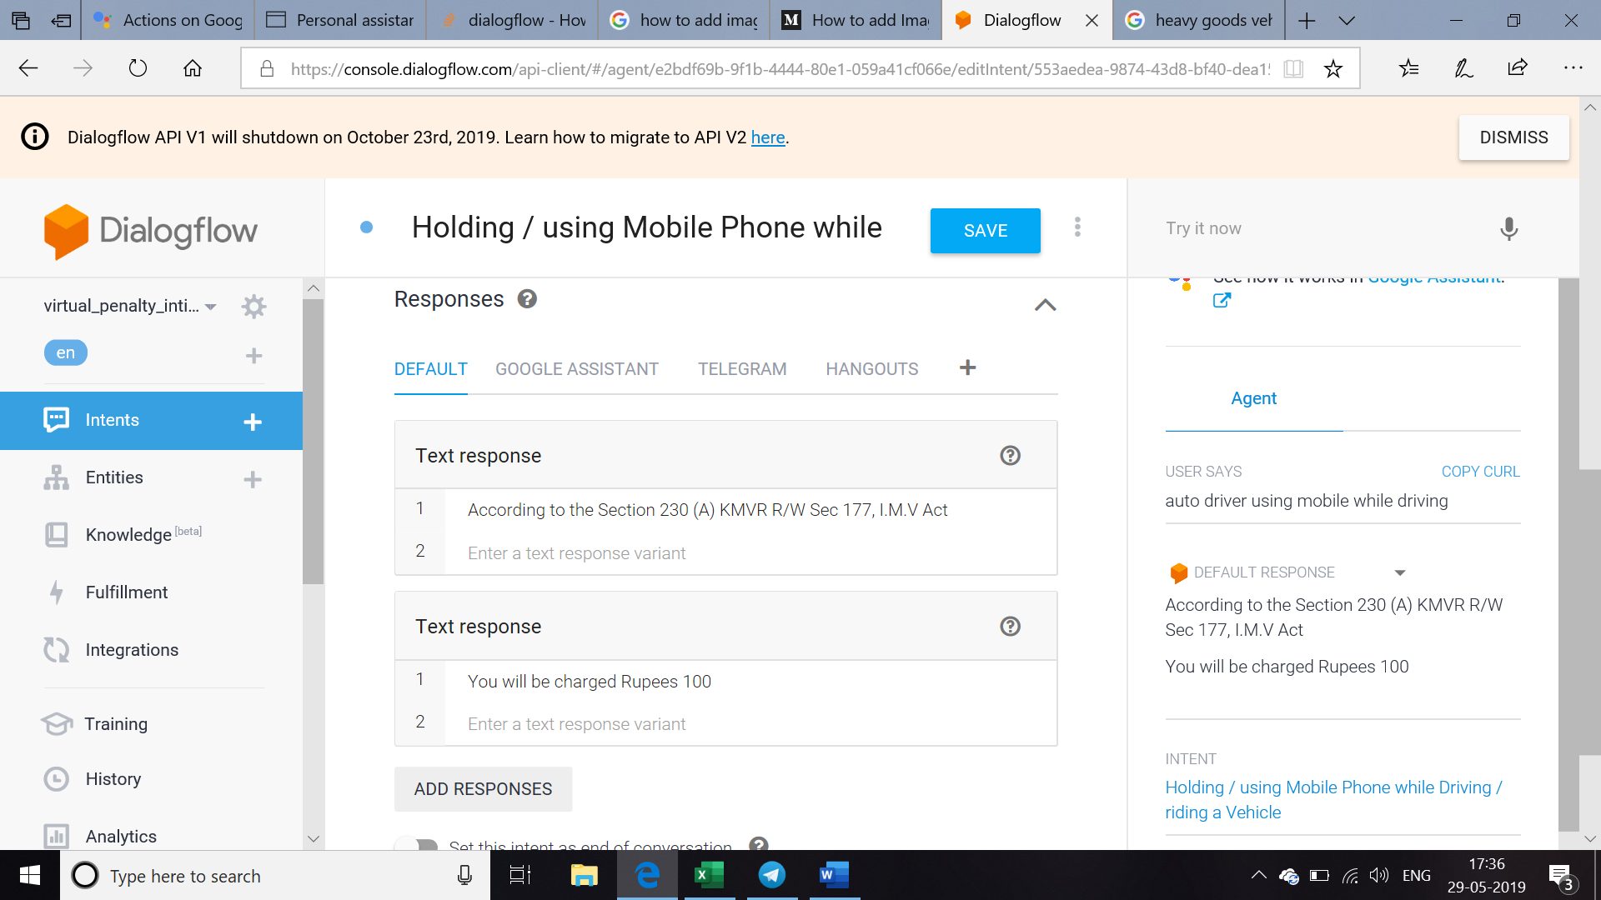

For creating two wheeler rules create a intent two wheeler and add the rules in the Responses as shown below

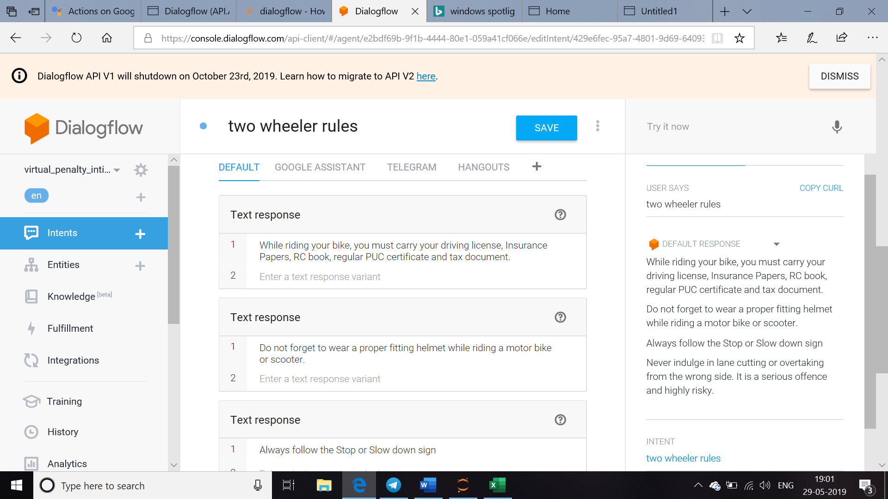

Similarly for four wheeler create a intent and add the respective rules in the Responses as shown below.

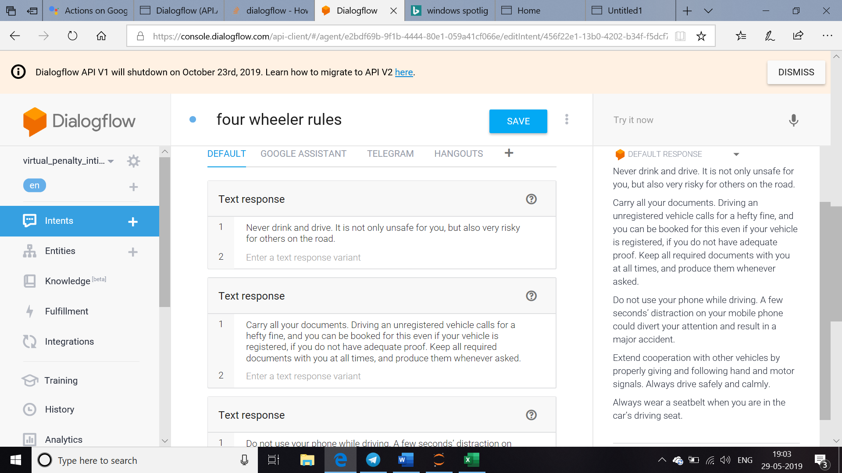

For each offence separate intents are created and managed . These are the list of offences that could be integrated for providing full information to the user.

